**OMS Web Portal Functional Specification**

**. . . . . . . . . . . . . . . . . . . . . . . . . . . . . . . . . . .**

**GEODIS Contract Logistics System**

Table of Contents

* Revision: 1.2
* Author: Mien Nguyen

(UC-001) Membership Management

(UC-002) Reward & Transaction Management

Customer

Loyalty

(UC-004) Reports

(UC-003) Services for

PoS Interface

1 Document Scope 3

1.1 Identification 3

1.2 Confidentiality 3

1.3 Abbreviation/Flow-Chart Symbol 3

1.4 Revision History 5

2 Solution 6

2.1 Overview 6

2.2 Architecture 6

3 OMS Web Portal Functionality 7

3.1 User Authentication 7

3.1.1 Log In/ Log Out 7

3.1.2 Change Password 7

3.2 Inventory Management 7

3.3 Order Management 8

3.3.1 View/Search Order 8

3.3.2 Create/Change/Cancel Order 9

3.4 Customer Management 10

3.4.1 View/Search Customer 10

3.4.2 Create/Change Customer 11

3.5 Report Management 11

3.5.1 Display Report 11

3.6 Administration Page (only for administrator) 12

3.6.1 Report Management 12

3.6.2 User Management 13

4 OMS Process Functionality 13

4.1 Handle Order 14

4.2 Get Order Status 14

4.3 Get Inventory Content 14

4.4 Handle Customer 14

5 OMS Web service functionality 14

5.1 Send Order 14

5.2 Get Order Status 14

5.3 Get Inventory Content 14

5.4 Send Customer 14

I. APPENDIX A 15

6 Acceptance 16

# Document Scope

## Identification

This document describes the implementation of Contract Logistics System by GEODIS. This document will be used as the base for implementation work to be done.

## Confidentiality

The classification of this document and its contents is ‘Commercial-in-Confidence’. All information contained in all sheets of this document constitutes a trade secret and/or information that are commercial or financial and privileged and confidential.

## Abbreviation/Flow-Chart Symbol

|  |  |
| --- | --- |
| Abbreviation/Symbol | Description |
| OMS | Order Management System |
|  | Process |
|  | Optional Process |
|  | Condition/Decision |

## 

## Revision History

|  |  |  |  |
| --- | --- | --- | --- |
| Rev. | Author | Date | Description |
| 1.0 | Mien Nguyen | 22/10/2016 | Create |
| 1.1 | Kenneth | 27/10/2016 | Update |
| 1.2 | Mien Nguyen | 29/10/2016 | Update |
|  |  |  |  |
|  |  |  |  |
|  |  |  |  |
|  |  |  |  |
|  |  |  |  |
|  |  |  |  |
|  |  |  |  |
|  |  |  |  |
|  |  |  |  |

# Solution

Develop Web Application in Laravel Framework

Application to have its own mySQL DB

MySQl Table Design provided in MySQL Diagram

## Overview

OMS Web Portal is a web site which allow user to perform:

* OMS online order function (Customer Order)
* OMS online real-time inventory with expiry date, inventory type, location (customer check available quantity before place order)
* Order type management (Normal; Back Order or Hold Order)
* Fulfillment Type management (All or Nothing; Fill and Kill (Product); Fill and Kill (QTY) or Partial Delivery)
* OMS master file management (customer create by customer via OMS)
* Add 5 more userfield (free type text) to each module if possible.

## Architecture

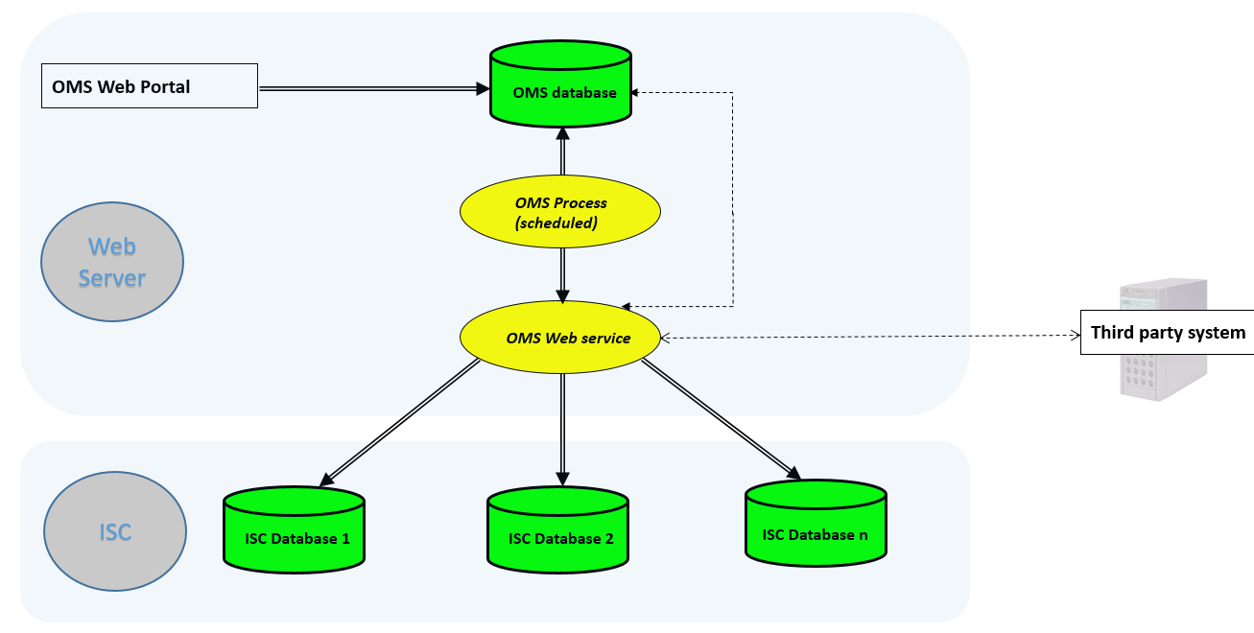

# OMS Web Portal Functionality

## User Authentication

The Host Server shall contain definitions for user names, passwords and access roles, e.g. Administrator role, User role and Guest role. These definitions shall be local to the Host Server only and shall be inaccessible from the Client in any form.

|  |  |
| --- | --- |
| **USER DEFINITION Header highlighted in YELLOW is MANDATORY** | |
| **Header** | **Description** |
| Username | User name |
| Password | Password |
| Role | User Roles: Normal user, Admin |
| Email | User’s email |
| CreateTime | Created Time |
| Status | Status |
| ExpiryDate | Expiry Date |

### Log In/ Log Out

The logon method shall be displayed at the user location. The logon shall succeed or fail. In case of a failure, a default authentication page shall be displayed. The logon shall be capable of cancellation. If cancelled the Home page shall be displayed. A logon failure shall redisplay the logon method with all field blank. The password as entered shall display the character '*' in place of each password character entered.

Each user will be mapped to specific projects and user will be able to interact with data of assigned project. User will be able to be tied to a connection field which will include the project tied to it.

After a successful login and the login page is displayed, all subsequent displayed pages shall contain a logout control. When activated the logout control shall display a control asking for confirmation of logout. If confirmation id denied the logout confirmation is removed with no effect. If confirmed the Home Page is displayed and all subordinate windows are closed.

### Change Password

User will be able to change password. This function will follow standard change password (password validation, Re-type password…)

## Inventory Management

Inventory will have the following fields (table included) with 5 additional userfields 1-5 to be able to turn on/off ( If possible, provide a new table or a configuration file for that, no need UI)

|  |  |
| --- | --- |
| **INVENTORY HEADERS DEFINITION Header highlighted in YELLOW is MANDATORY** | |
| **Header** | **Description** |
| ItemID | Item ID |
| Description | Item Description |
| Category | Item Category |
| Size | Item Size |
| Weight | Weight |
| Color | Color |
| Gender | Gender |
| Brand | Brand |
| AvailableQty | Available Quantity |
| OnHoldQty | Picking/Transferring/Adjusting Quantity |
| OnReceiptQty | Quantity of item which is still on RO, not confirmed on ISC yet |
| DamagedQty | Damaged quantity |

Search function: User will be able to do search functions with criteria: Item ID, Description, Category, Brand, Status (All/On Hold/On Receipt/Damaged) and 5 user fields (can be turned on/off) ( If possible, provide a new table or a configuration file for that, no need UI)

## Order Management

Order will have the following fields (table included) with 3 additional userfields 1-3 to be able to turn on/off. ( If possible, provide a new table or a configuration file for that, no need UI)

|  |  |
| --- | --- |
| **SALES ORDER HEADERS DEFINITION Header highlighted in YELLOW is MANDATORY** | |
| **Header** | **Description** |
| Storer Code | Storer Code |
| Expected Delivery Date | Expected order delivery date |
| Order Type | Order Type. Values: Normal/Back Order/Hold Order |
| Fulfillment Type | Fulfillment Type: Values: All or Nothing; Fill and Kill (Product); Fill and Kill (QTY) or Partial Delivery |
| Order Status | Order Status |
| Recipient Code | Recipient Code preset in system |
| Product Code | Product Code preset in system |
| Quantity | Ordered quantity |

### View/Search Order

User will be able to see the list of orders and their status (Created/Processing/Finished) on OMS. This status will be retrieved from WMS via web service. Fields of Sales Order to be displayed: Sales Order ID, Sales Order No, Storer Code, Expected Delivery Date, Order Type, Fulfilment Type, Order Status, Recipient Code, Rec Address 1, Rec Address 2, Rec Address 3, Rec Address 4, Rec Country, Rec Zip, Rec Contact, Rec Remark, Rec Name. Fields of Sales Order Detail to be displayed (by grid): Seq No, Product Code, Order Quantity, Delivery Quantity, Lot No, Serial No, Attribute 1, Attribute 2, Attribute 3, Attribute 4, Attribute 5.

Search function will be implemented to help user find a specific order base on basic information.

|  |  |
| --- | --- |
| ORDER SEARCH SCREEN CONTROLS | |
| **Field** | **Control** |
| Order Number | Text box |
| Expected Delivery Date | Datetime picker |
| Order Type | Dropdown List. Values: Normal/Back Order/Hold Order |
| Fulfillment Type | Dropdown List: Values: All or Nothing; Fill and Kill (Product); Fill and Kill (QTY) or Partial Delivery |
| Recipient Code | Text box (can be suggested) |
| Order Status | Dropdown List. Values: Created/Started/Picked/Packed/Completed/Cancelled |
| Search | Button |

### Create/Change/Cancel Order

User will be able to create normal order in OMS with ship-to name, ship-to code, ship-to address, request delivery date, route code, items code, descriptions, Qty etc.

|  |  |
| --- | --- |
| SALES ORDER CREATE/UPDATE SCREEN CONTROLS | |
| **Field** | **Control** |
| Storer Code | Text box |
| Expected Delivery Date | - Text box  - By default, expected delivery date will follow Storer setting if blank |
| Order Type | - Choose from drop down box: Normal; Back Order or Hold Order - By default, order type will follow Storer setting if blank |
| Fulfillment Type | - Choose from drop down box: All or Nothing; Fill and Kill (Product); Fill and Kill (QTY) or Partial Delivery - By default, system set Normal and Back Order as All or Nothing; Hold Order as Partial Delivery - No default setting available for Storer yet |
| Recipient Code | - Textbox  - Must map with Customer Code preset in system (can be suggested) |
| Product Code | - Text box  - Map with Item Code preset in system (can be suggested) |
| Quantity | - Text box  - Ordered quantity |
| Save | - Button |
| Cancel | - Button |
| Import | - Button. Import sales order detail from csv file |

The order will be stored into OMS database and sent to WMS for processing. User will be able to change/cancel the order before ISC start processing DO.

Inventory validation will be implemented: if inventory is not enough for the order (base on available quantity), prompt message to inform user and not allow user to save the order. If order type is Back Order, no need to do inventory validation.

Sales Order detail can be imported from csv file (tab delimiter) base on this pattern.



## Customer Management

Customer screen will have the following fields (table included) with 3 additional userfields 1-3 to be able to turn on/off.

|  |  |
| --- | --- |
| **Customer HEADERS DEFINITION ** Header highlighted in YELLOW is MANDATORY \*\*** | |
| **Header** | **Description** |
| Storer Code | - Storer Code |
| Customer Code | - Max length = 250 characters |
| Primary Company Name | - Max length = 250 characters |
| Primary Address | - Max length = 250 characters |
| Primary Country | - Max length = 250 characters |
| Primary Region Code | - Please refer to Region Code worksheet for list of region codes |
| Primary Contact First Name | - Max length = 250 characters |
| Primary Contact Last Name | - Max length = 250 characters |
| Primary Contact Phone | - Max length = 250 characters |
| Is Active | - Yes (1) or No (0) |

### View/Search Customer

User will be able to see the list of customers and customer status (Active/Inactive) of their project on OMS. User are also able view detail of customer. Fields of Customer to be displayed: Customer ID, Storer Code, Customer Code, Company Name 1, Address 1, Country 1, Region Code 1, ContactFirstName1, ContactLastName1, ContactPhone1, IsActive.

Search function will be implemented to help user find a specific order base on basic information.

|  |  |
| --- | --- |
| CUSTOMER SEARCH SCREEN CONTROL | |
| **Field** | **Control** |
| Customer Code | - Text box |
| Primary Company Name | - Text box |
| Primary Address | - Text box |
| Primary Country | - Country Dropdown List (with All option) |
| Primary Region Code | - Text box |
| Primary Contact First Name | - Text box |
| Primary Contact Last Name | - Text box |
| Primary Contact Phone | - Text box |
| Is Active | - Check box |
| Search | - Button |

### Create/Change Customer

User will be able to create a customer in OMS. The order will be stored into OMS database and sent over to WMS.

|  |  |
| --- | --- |
| CUSTOMER CREATE/UPDATE SCREEN CONTROL | |
| **Field** | **Control** |
| Customer Code | - Text box  - Read-only if in UPDATE mode |
| Primary Company Name | - Text box |
| Primary Address | - Text box |
| Primary Country | - Country Dropdown List |
| Primary Region Code | - Text box |
| Primary Contact First Name | - Text box |
| Primary Contact Last Name | - Text box |
| Primary Contact Phone | - Text box |
| Is Active | - Check box |
| Save | - Button |
| Cancel | - Button |

## Report Management

### Display Report

Report screen will have the following fields:

|  |  |
| --- | --- |
| **REPORT HEADERS DEFINITION ** Header highlighted in YELLOW is MANDATORY \*\*** | |
| **Header** | **Description** |
| Report ID | - Report ID |
| Report Name | - Report Name |
| Query | - Query. Max length = 1000 characters |
| Status | - Active/Inactive |

User will be able to run SQL query based on connection and return result in table format and able to export the table to excel csv.

|  |  |
| --- | --- |
| REPORTING SCREEN CONTROL | |
| **Field** | **Control** |
| Report Name | - Dropdown List |
| Result | - Table |
| Export To Excel | - Button |
| Display Report | - Button |

## Administration Page (only for administrator)

### Report Management

Report properties and queries will be stored in OMS database. Admin will be able to create, delete and edit reports on Report Management screen.

|  |  |
| --- | --- |
| REPORT CREATE/UPDATE SCREEN CONTROL | |
| **Field** | **Control** |
| Report Name | - Text box |
| Query | - Multiple lines text box |
| Status | - Check box (Active/Inactive) |
| Save | - Button |
| Cancel | - Button |

First report will be items master report.

Example 1:

SELECT TOP 10 [project_id]

,[sku_grp]

,[sku]

,[description]

,[status]

,[alt_sku]

,[alt_description]

,[barcode]

,[user_field1]

,[user_field2]

,[user_field3]

,[user_field4]

,[user_field5]

FROM item_master

### User Management

Administrator will be able to view/create/change/delete OMS user.

|  |  |
| --- | --- |
| USER CREATE/UPDATE SCREEN CONTROL | |
| **Field** | **Control** |
| Username | - Text box |
| Password | - Password Text box  - Follow standard rules |
| Connector | - Dropdown List  - Linked to Connector table |
| Role | - Dropdown List  - Administrator/User |
| Status | - Dropdown List  - Values: Active/Expired/Locked |
| Save | - Button |
| Cancel | - Button |

### Connector Management

Administrator will be able to view/create/change/delete OMS Connector.

|  |  |
| --- | --- |
| CONNECTOR CREATE/UPDATE SCREEN CONTROL | |
| **Field** | **Control** |
| Connector ID | - Textbox |
| Project ID | - Project ID |
| Project Name | - Dropdown List  - Linked to Connector table |
| IP Address | - Dropdown List  - Administrator/User |
| Database Name | - Checkbox  - Values: Active/Inactive |
| Save | - Button |
| Cancel | - Button |

# OMS Process Functionality

**This portion is to be insource/outsource after section 3 is completed**

## Handle Order

Get orders from OMS database and call OMS web service to send orders to ISC system. . (sp to update ISC database)

## Get Order Status

Call OMS web service to get order status from ISC system and update to OMS database

## Get Inventory Content

Call OMS web service to get inventory content from ISC system and update to OMS database

## Handle Customer

Get customer from OMS database and call OMS web service to send customer to ISC system.. (sp to update ISC database)

# OMS Web service functionality

**This portion is to be insource/outsource after section 3 is completed**

Python Web Service

DB Connection to ISC Sql Server 2008 R2

## Send Order

Connect to designated ISC database and execute store procedure to insert order into ISC database.

## Get Order Status

Get order status (Order status and detail lines) from designated ISC.

## Get Inventory Content

Get inventory content from designated ISC system.

## Send Customer

Connect to designated ISC database and execute store procedure to insert customer into ISC database.

# APPENDIX A

|  |  |
| --- | --- |
| Web OMS Outbound Order Status | |
| 10 | Created |
| 20 | Started |
| 30 | Picked/Packed |
| 40 | Completed |
| 90 | Cancelled |

# APPENDIX B – Database

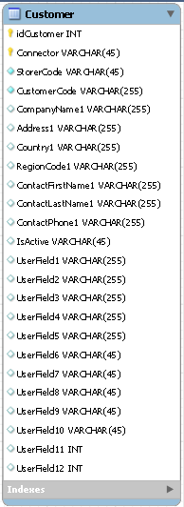 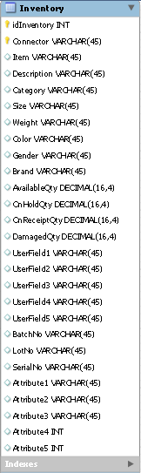

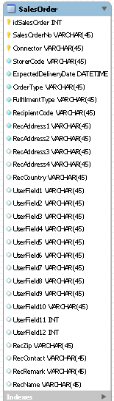 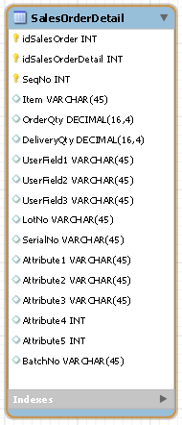 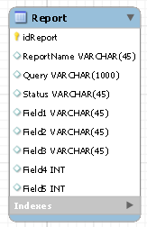

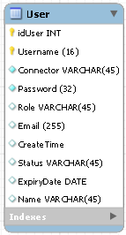 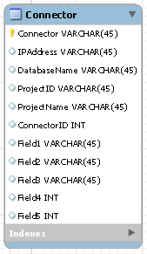

# Acceptance

**Offered by:** **Accepted by:**

By __________________________ By__________________________

Authorized Signature Authorized Signature

___________________________ _________________________

Name (Type or Print) Name (Type or Print)

___________________________ _________________________

Date Date

By__________________________ By__________________________

Authorized Signature Authorized Signature

___________________________ _________________________

Name (Type or Print) Name (Type or Print)

___________________________ _________________________

Date Date